Chapter & Scripts

Home & Living

Finding a Place to Live

03.15
Apt Exterior：公寓楼外部区域

Lease & Renting

Home Maintenance & Repairs

Cabinets：橱柜; Tile：瓷砖; Trims：门框
Ventilation：通风;Plumbing：下水管;Heat Complaint：暖气问题
Bedbugs：臭虫;Extermination：灭虫

Utilities (Electricity, Gas, Water)

Furniture & Household Items
Appliance：家用电器

Utilities (Electricity, Gas, Water)

Furniture & Household Items

Food & Daily Needs

Grocery Shopping

Cooking & Kitchen Vocabulary

03/16
- Broil (grill the top)
  - strong heat from the TOP of the oven only
- Lasagna button (oven preset program)

Restaurants & Dining

03/16
- Caviar 鱼子酱
- Herring 鲱鱼

Coffee Shops & Cafes

Food Delivery & Takeout

Transportation

Driving & Car Vocabulary

Public Transportation

03.16
hold on to the pole 把杆子抓住; could you let me through? 借过一下;Tunnel /ˈtʌnəl/ 隧道
Ramp 斜坡;mezzanine & platform 站厅层 / 站台
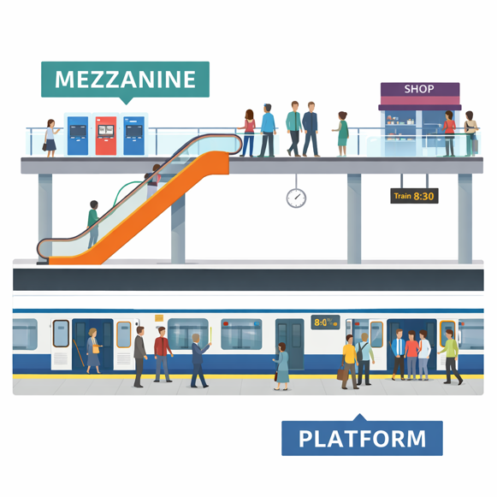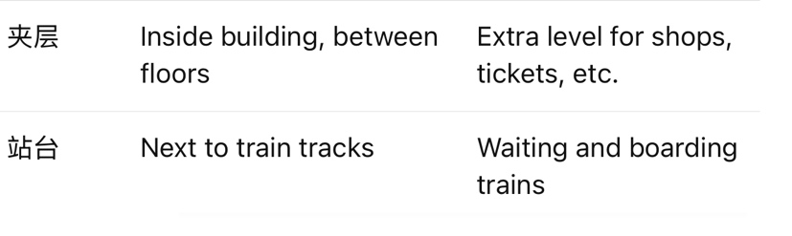

Ride Apps (Uber, Lyft)

Gas Stations & Car Maintenance

Parking & Traffic

Work & Career

Job Search

Workplace Communication

03/16
- Tech Hub /tek hʌb/ 科技中心
- XFN (Cross-Functional Partner): A colleague from another team or department who collaborates on a project
- Heuristic: A practical approach to problem-solving that is not guaranteed to be perfect but helps find solutions quickly.
- Nonrigorous: 不严谨的 Lacking strict logic, accuracy, or formal structure.

Meetings & Presentations

Emails & Professional Writing

Office Culture

Money & Finance

Banking

Credit Cards

Payments & Bills

Taxes

Investments & Savings

Shopping & Services

Online Shopping

Clothing & Fashion

Returns & Refunds

Customer Service

Delivery & Packages

Health & Medical

Doctor Visits

Pharmacy & Medicine

Health Insurance

Symptoms & Illness

Emergency Medical

Travel

Flights & Airports

03/16
Standby
- 想提前上机：买了15:00机票但想早点上飞机
- 员工票：每一班飞机排 standby 等空位

Hotels & Accommodation

Travel Planning

Directions & Navigation

Tourism & Attractions
Bellevue美丽的景色 / 美景: From French meaning "beautiful view". Often used as a place name or to describe scenic views.

Technology

Smartphones & Apps

Internet & WiFi

Computers & Software

Tech Support

Social Life

Small Talk

03.15
Sketchy:阴森森的；livable：宜居的

03.16
Everyone needs to get a grip
每个人都要冷静点

Invitations & Events

Dating & Relationships

Hobbies & Entertainment
Ball-Jointed Doll (BJD) 球形关节人偶 : A type of articulated doll connected by ball joints, popular among collectors and hobbyists.

Body & Gestures
Fist 拳头

Government & Legal

Immigration & Documents

03.16
Attestation 证明 / 公证证明

Safety & Emergency

